Report Number: R5

A

REPORT

ON

ROADWAY-POWERED ELECTRIC VEHICLES

SUBMITTED BY:

PURUSHOTTAM THAKUR

BIPIN PRASAD DEVKOTA

APEKSHYA SHAKYA

DEPARTMENT OF ELECTRICAL ENGINEERING

IOE PULCHOWK CAMUS

PULCHOWK, LALITPUR

AUGUST 7, 2023

Report Number: R5

A REPORT

ON

ROADWAY-POWERED ELECTRIC VEHICLES

SUBMITTED TO:

VIJAY KUMAR YADAV

ASSOCIATE PROFESSOR OF ENGLISH

SUBMITTED BY:

PURUSHOTTAM THAKUR

BIPIN PRASAD DEVKOTA

APEKSHYA SHAKYA

APPROVED BY:

SANJAY SHARMA

DIRECTOR

BPA ENGINEERING CONSULTANCY

PULCHOWK, LALITPUR

AUGUST 7, 2023

**LETTER OF TRANSMITTAL**

DEPARTMENT OF SCIENCE AND HUMANITIES

I.O.E PULCHWOK CAMPUS

Lalitpur

August 7, 2023

Vijay Kumar Yadav

ASSOCIATE PROFESSOR OF ENGLISH

TRIBHUVAN UNIVERSITY, KIRTIPUR

Dear Yadav:

I submit the accompanying report entitled “Roadway-Powered Electric Vehicle” as the final project for Communication English.

The report discusses the characteristics of roadway-powered electric vehicle i.e., wireless charging technology, its background, and its significance in the context of the growing electric vehicle market. We have made the effort to introduce roadway wireless charging technology, its background, and its significance in the context of the growing electric vehicle market.

Recent information about roadway wireless technology and most recent data provided by the researchers and engineers working on this project for the last 10 years is incorporated in the project.

We are indebted to Mr. Bidur Khanal who is a senior engineer at Wi-Tricity (Company of Automotive solution) who has allowed me to take some valuable data regarding this project.

Yours sincerely

Bipin Prasad Devkota Purushuttom Thakur Apekshya Shakya

Students, IOE, Pulchowk campus

Enclosure: Report

**Acknowledgement**

We would like to express our deepest appreciation to all those who provided us with the opportunity to complete this report. A special gratitude gave to our Associate professor of English, Mr. Vijay Kumar Yadav who provided us this valuable opportunity to involve in writing a report on this interested topic.

Furthermore, I would also like to acknowledge with much appreciation the crucial role of the staff of Yatri (The electric vehicle company of Nepal), who gave the permission to use all the required equipment and the necessary material to complete this task “Collecting data of possibility of roadway wireless power transform”. Our special thanks to our teammate Purshottam Thakur, who helped us to assemble the parts and gave suggestions about the task “Visit electric vehicle company”. Finally, many thanks to the head of the project, Mr. Bipin Devkota, who invested his full effort in guiding the team in achieving the goal. We must appreciate the guidance given by other supervisors as well as the panels, especially in our project presentation that has improved our presentation skills thanks to their comments and advises.

**TABLE OF CONTENTS**

LETTER OF TRANSMITTAL.......................................................................................(ii)

ACKNOWLEDGEMENTS............................................................................................(iii)

ABSTRACT.....................................................................................................................(v)

1. INTRODUCTION....................................................................................................1

1.1 Purpose...........................................................................................................1 1.2 Background....................................................................................................1

1.3 Methods..........................................................................................................1

1.4 Importance......................................................................................................1

2. DISCUSSION...........................................................................................................2

2.1 Working Principle..........................................................................................3

2.2 Inductive Power Transfer...............................................................................4

2.3 Static Charging...............................................................................................5

2.4 Dynamic Charging.........................................................................................6

3. CONCLUSION........................................................................................................9

4. RECOMMENDATIONS........................................................................................10

5. GLOSSARY...........................................................................................................11

6. INDEX....................................................................................................................12

7. REFERENCES.......................................................................................................13

List of Illustrations

Figure 1: WPTS.................................................................................................................4

Figure 2: Efficiency...........................................................................................................5

Figure 3: Block Diagram of inductive Power Transfer.....................................................6

Figure 4: Schematic Diagram of Static WPT.....................................................................7

Figure 5: Schematic Diagram of DWC..............................................................................8

Figure 6: Working data sheet ……………………………………………………………9

**ABSTRACT**

This report describes the working principles, construction and design of the electric vehicles. It attempts to find the various reasons for choosing it instead of diesel engine vehicles. It deals with the losses of the electric machines used in the construction of the electric vehicles and tries the various ways to find the solution of the losses to minimize these problems. This report also tries to highlight the importance of electric vehicles (EV). It deals with the power factors, its’ importance and proper working of the electric motors and various other electric machines used in its’ construction.

**1** **INTRODUCTION**

**1.1** **Purpose**

This report aims to provide power to electric vehicles wirelessly. Additionally, this report on roadway powered electric vehicles is to explore and analyze the feasibility, benefits, challenges, and potential implementation strategies of this innovative transportation technology.

**1.2** **Background**

The concept of electric vehicles started with the invention of the battery by Italian physicist Alessandro Volta in 1800. In the 1830s, Scotsman Robert Anderson built the first crude electric carriage using non-rechargeable batteries. Later, in the 1850s and 1860s, several inventors and engineers developed electric-powered vehicles, including trams and small cars.

The late 1800s and early 1900s saw a surge in the popularity of electric vehicles, especially in urban areas. Electric cars were considered more comfortable and easier to operate than their early internal combustion engine counterparts. In 1884, Thomas Parker, a British inventor, built the first practical production electric car.

The history of electric vehicles shows a cyclical pattern of popularity and decline, but the increasing focus on sustainability and technological advancements have brought electric cars to the forefront of the automotive industry, paving the way for a more sustainable transportation future.

**1.3** **Methods**

Even though the project has tried to cover all that has been possible in the context of its topic, it has a few limitations in the form of limited hands in terms of concept of roadway powered electric vehicle. Data have been mainly collected from the richly equipped learning center and internet.

**1.4** **Importance**

Wireless electric vehicles (EVs) offer several advantages over traditional plug-in Evs that rely on physical connections for charging. Here are some of the key advantages of wireless electric vehicles:

1. Convenience: Wireless charging eliminates the need for physical cables and connectors, making the charging process more convenient and user-friendly. EV owners can simply park their vehicles over a wireless charging pad, and the charging process initiates automatically without any manual intervention.
2. Ease of use: With wireless charging, there is no need to handle heavy charging cables or find charging stations with available plugs. This simplifies the charging process, especially for individuals who may have physical limitations or mobility issues.
3. Reduced wear and tear: Physical charging connectors on plug-in EVs’ can experience wear and tear over time due to repeated plugging and unplugging. In contrast, wireless charging eliminates this concern, as there are no physical connectors to degrade or become damaged.
4. Increased efficiency: Wireless charging systems have improved over the years, and modern technology allows for high-efficiency power transfer. This means that wireless charging can be just as efficient as traditional plug-in charging methods, resulting in less energy loss during the charging process.
5. Enhanced safety: Wireless charging eliminates the risk of electrical shock or short circuits that can occur with physical connectors. There is no exposure to live electrical components, reducing potential hazards during the charging process.
6. Flexibility and scalability: Wireless charging pads can be installed in various locations, including private garages, public parking lots, and even roadways. This flexibility allows for more widespread adoption of EVs’; as drivers have more options for charging their vehicles.
7. Autonomous charging: Wireless charging can be integrated with autonomous driving technology, enabling self-driving EVs’ to navigate and park themselves over charging pads for automated charging. This feature adds to the convenience and futuristic appeal of wireless electric vehicles.

It’s important to note that wireless charging for EVs’ is still a developing technology, and there are some challenges to overcome, such as the cost of infrastructure deployment and the need for standardization. However, as technology continues to advance, wireless electric vehicles have the potential to offer significant advantages in terms of convenience, ease of use, and safety.

**2.** **DISCUSSION**

The report on “Roadway-Powered Electric Vehicles” contains the concepts of the working principles of electric vehicles. There are various parts in the electric vehicles which are responsible for the vehicles to move on the road. Electric vehicles consist of electric motors that are powered by a battery pack. The main advantage of electric vehicles is that they emit zero emissions and are eco-friendly. They also do not consume any fossil fuels and use a sustainable form of energy to power their car. The main components of electric vehicles are:

1. Traction Battery Pack

2. Dc -Dc converter

3. Electric motor

4. Power inverter

5. Charging port

6. Inboard charge

7. Controller

8. Auxiliary Battery

9. Thermal system

10. Transmission

**1. Traction Battery pack:** A traction battery pack is also known as an Electric Vehicle Battery (EVB). It powers the electric motors of an electric vehicle. The battery acts as an electrical storage system. It stores energy in the form of DC current. The range will be higher with increasing kW of the battery. The life and operation of the battery depends on its design. The lifetime of a traction battery pack is estimated to be 200,000 Miles.

**2. Dc to dc converter:** The traction battery pack delivers a constant voltage. But different components of the vehicle have different requirements. The DC-DC converter distributes the output power that is coming from the battery to a required level. It also provides the voltage required to charge the auxiliary battery.

**3. Electric motor**: The electric traction motor is the main component of an electric vehicle. The motor converts electrical energy into kinetic energy. This energy rotates the wheels. An electric motor is the main component that differentiates an electric car from a conventional car. An important feature of an electric motor is the regenerative braking mechanism. This mechanism slows down the vehicle by converting its kinetic energy into another form and storing it for future use. There are basically two types of motors DC and AC motors.

**4. Power inverter:** It converts DC power from the batteries to AC power. It also converts the AC current generated during regenerative braking into a DC current. This is further used to recharge the batteries.

**5. Charging port:** The charge port connects the electric vehicle to an external supply. It charges the battery pack. The charge port is sometimes located in the front or rear part of the vehicle.

**6. Onboard charge:** The onboard charger is used to convert the AC supply received from the charge port to the DC supply. The onboard charger is located and installed inside the car. It monitors various battery characteristics and controls the current flowing inside the battery pack.

**7. Controller:** The power electronics controller determines the working of an electric car. It performs the regulation of electrical energy from the batteries to the electric motors. The pedal set by the driver determines the speed of the vehicle and the frequency of variation of voltage that is input to the motor. It also controls the torque produced.

**8. Auxiliary battery:** Auxiliary batteries are the source of electrical energy for the accessories in electric vehicles. Without the main battery, the auxiliary batteries will continue to charge the car. It prevents the voltage drop, produced during engine start from affecting the electrical system.

**9. Thermal cooling system:** The thermal management system is responsible for maintaining an operating temperature for the main components of an electric vehicle such as an electric motor, controller, etc. It functions during charging as well to obtain maximum performance. It uses a combination of thermoelectric cooling, forced air cooling, and liquid cooling.

**10. Transmission:** It is used to transfer the mechanical power from the electric motor to the wheels, through a gearbox. The advantage of electric cars is that they do not require multi-speed transmissions. The transmission efficiency should be high to avoid power loss.

**2.1. Working principle**

Recent developments of electric vehicle technologies have largely been driven by requirements to reduce emissions of greenhouse gases (GHG) such as CO2 and to mitigate air pollution especially in urban areas. Various electric vehicles use batteries for energy storage therefore heavily rely on the available battery products and their technology development. Hybrid Electric Vehicles (HEV) are also gaining popularity due to the limited use of the battery for short term energy recovery.

In contrast, roadway powered electric vehicles (RPEV) among other electric vehicles do not necessarily require battery energy storage for their traction as they are using dynamic wireless power transfer systems (WPTS) to get the power as they are moving on roads. This is seen as a promising candidate for future propulsion of small cars, taxis, buses, trams, trucks and trains. It can even be competitive with internal combustion engine powered vehicles.

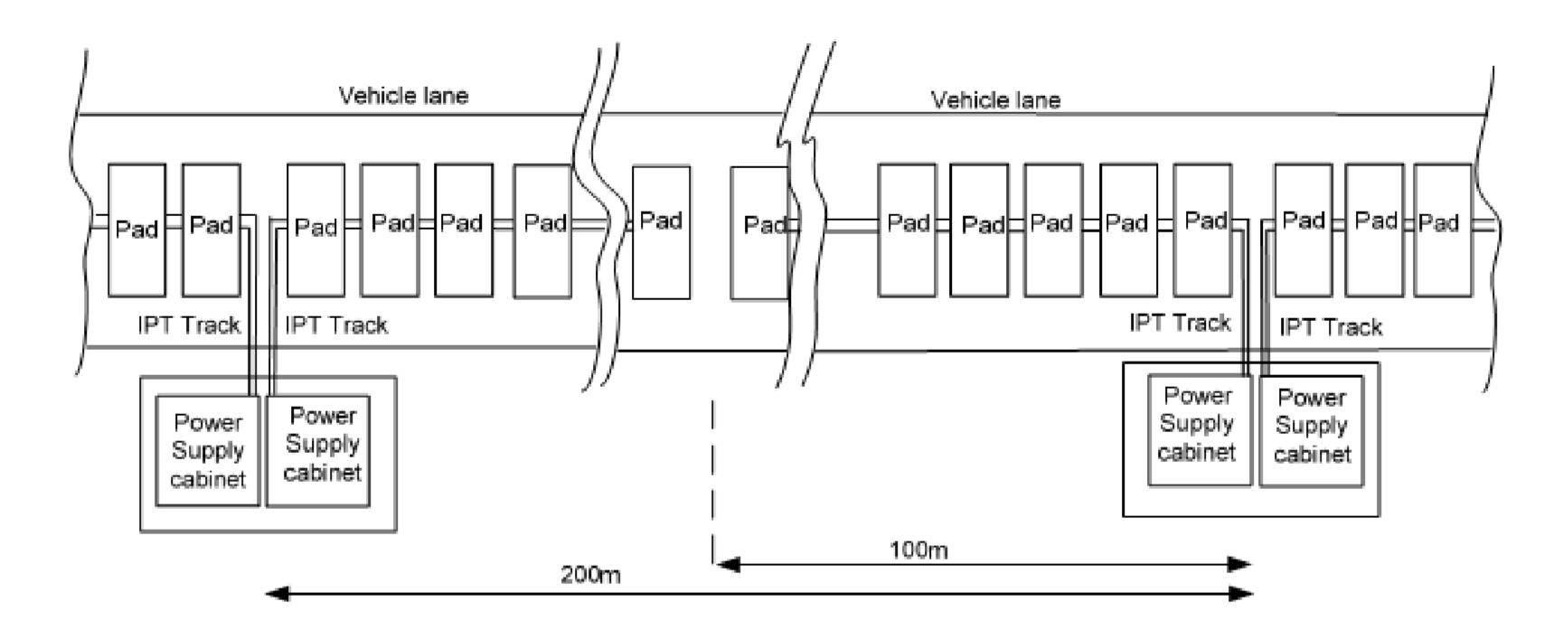

Fig: 1

Various WPTS have been developed for RPEV. Among them, one noteworthy technology is the inductive power transfer systems (IPTS). Various IPTS systems have been proposed for stationary or static and dynamic charging of electric vehicles wirelessly since 1990s including those developed by Auckland University in which a circular or rectangular type coil is used as the primary coil with various secondary coils (such as circular types or double-sided types and single-sided polarized coils with an additional coil for enhanced performance for high power transfer).

Circular coils have the merits of a compact structure, lower weight and lower electromagnetic field (EMF) but can be limited by power transfer capacity and less lateral tolerance. Instead, rectangular core plates have potentially higher coupling factors and large lateral tolerances. Due to the adoption of many smaller power pads (see Fig.1 below), to avoid unwanted energizing and loading, these systems have a higher deployment and maintenance cost for the ground power pads and control complexity.

WPT is divided into far-field and near-field WPT techniques based on the transferring distance of inducing power. Further, these two WPT systems are classified into six types based on the employed transferring medium. Far field charging types are microwave and laser, and near-field charging types Capacitive Coupling Wireless Power Transfer (CCWPT), Coupled Magnetic Resonance (CMR), Inductive Power Transfer (IPT), and Permanent Magnet Coupled transfer (PMC). Microwave and laser technologies fall under the category of far-field wireless technology, whereas IPT, CMR, and PMC come under the category of near-field wireless technology. Based on the vehicles’ mobility state, WPT is classified into two methods. The first method is static WPT while the vehicle is in a stand-alone state and the second method is dynamic WPT when the vehicle is in a mobile condition. Each method of WPT is important for different applications. As a result, it is challenging to propose an efficient method for a particular application. CMR is more suitable for lower-power applications, whereas IPT is more suitable for high-power applications without any resonant circuit. WPT techniques can achieve 85–96% efficiency with less airgap between the primary and secondary coils. If the airgap increases, then the power flow efficiency automatically decreases. More research is going to improve efficiency by increasing the airgap distance of the transmitter and receiver coils. More attention is needed to maintain the proper efficiency in a large airgap concerning the magnetic coupling coefficient. If the magnetic coupling coefficient values are high, it is possible to achieve valuable efficiency, greater than 90%.

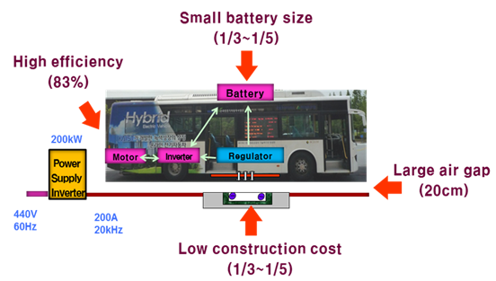

Figure 2: Efficiency

**2.2**  **Inductive Power Transfer**

Inductive power transfer works based on electromagnetic induction within airgaps, as discussed in. However, Lenz’s law and Faraday’s law are the key principles for the inductive type of power sharing. According to the law, time-varying current passes through a conductor (transmitter), producing an electromagnetic field around the conductor. Due to this, the secondary coil (receiver) receives electromotive force. Then, the secondary coil is attached to the battery or load, and power is transferred throughout the circuit without any physical contact. Transmitting and receiving the electromotive force can be achieved by using the proper magnetic materials. [**Figure 6**](https://www.mdpi.com/1996-1073/16/7/3084#fig_body_display_energies-16-03084-f006) shows an experimental block diagram of the inductive-based power transfer technique.

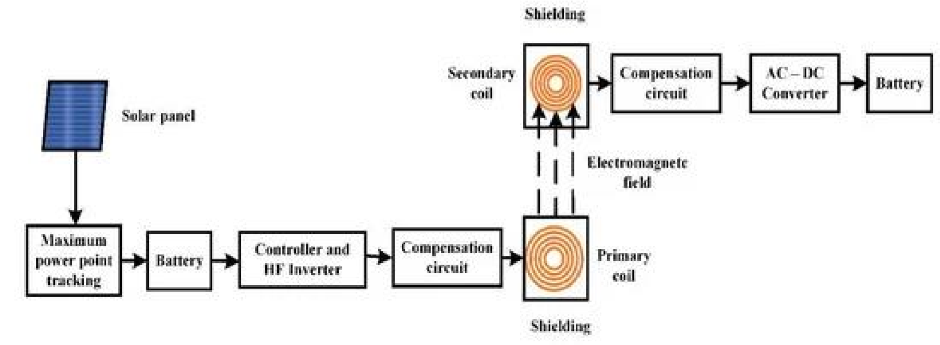

**Figure 3.** Block diagram of the inductive power transfer.

Initially, Oersted introduced electromagnetism and electromagnetic field generation around the current-carrying conductor.

**2.2 Static Charging**

Static charging systems work under a similar principle to IPT. This charging method can be implemented in vehicle parking areas, traffic signals, and toll plazas. Lukic and Pantic described the present static wireless charging system and consolidated the improvement of industry-wide standard guidelines by the SAE. Efficiency-wise, static wireless charging is more suitable for EVs. In static WPT, efficiency may be affected because of transmitter and receiver coil misalignment. It is possible to overcome this with mechanical and proper compensation technologies.

Many researchers contribute to eliminating the misalignment problems in static WPT. [**Figure 7**](https://www.mdpi.com/1996-1073/16/7/3084#fig_body_display_energies-16-03084-f007) shows the schematic diagram of the static WPT of EV. The system’s efficacy can be improved by concentrating on each conversion stage. The whole block diagram is split into two stages. The initial stage consists of input power like a DC or AC source and a high-frequency inverter. If the input power is AC, it should be converted into DC with power factor correction and shared with the high-frequency inverter. Inductive power transfer needs only AC power at a high frequency to achieve efficient power transfer. Solar or DC input power can be directly shared with the high frequency inverter, as in the proposed system by the authors of. Then an inverter converts the DC power into high-frequency AC power. We can achieve up to 97% efficiency using the above technique.

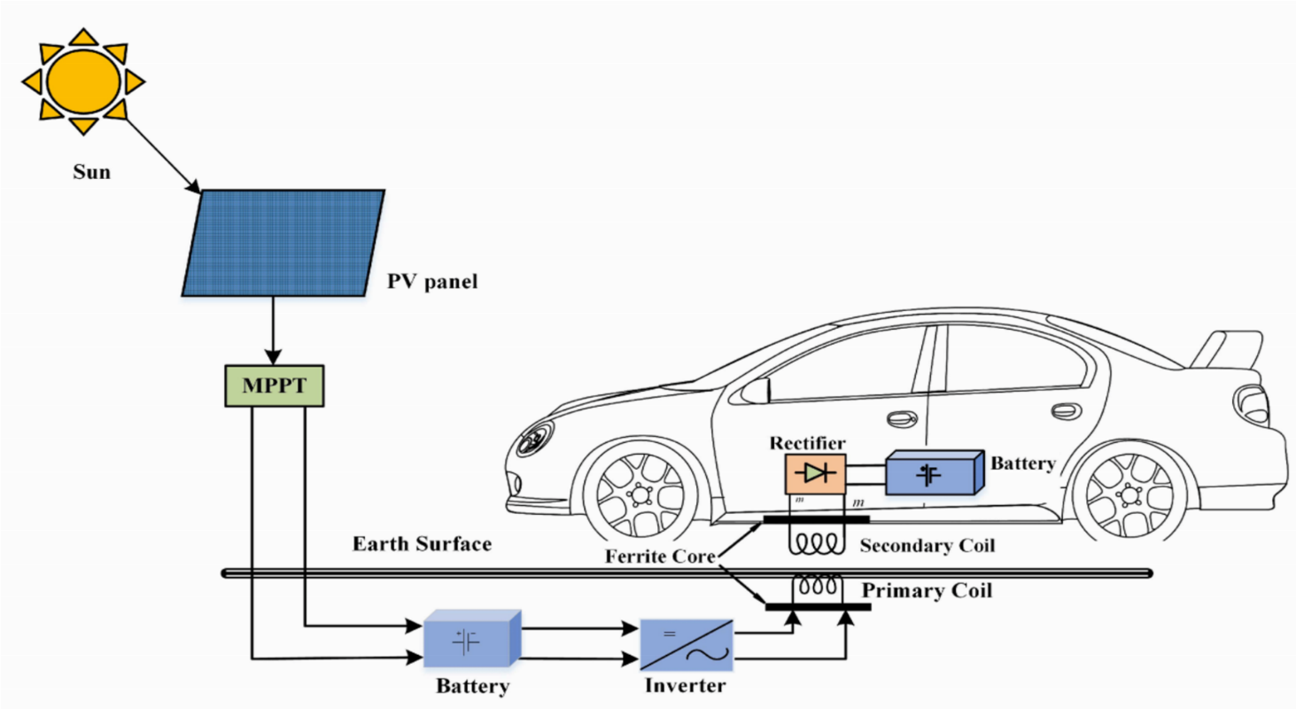

**Figure 4.** Schematic diagram of static WPT.

# **2.3 Dynamic Charging**

A vehicle can be charged in the mobile state by using DWC. This type of charging reduces the buffer time for charging the vehicle. It was implemented in 1978 by Bolger. DWC eliminates EV charging problems such as continuous power sharing, current-controlled inverters, and Electromotive Force (EMF) characteristics. Additionally, DWC reduces most of the non-technical problems that occur in EV, like the cost, size, and weight of the battery. This charging concept confines the magnetic coupling between the primary coil below the floor’s surface and the secondary coil installed under the vehicle chassis shows the schematic diagram of DWC.

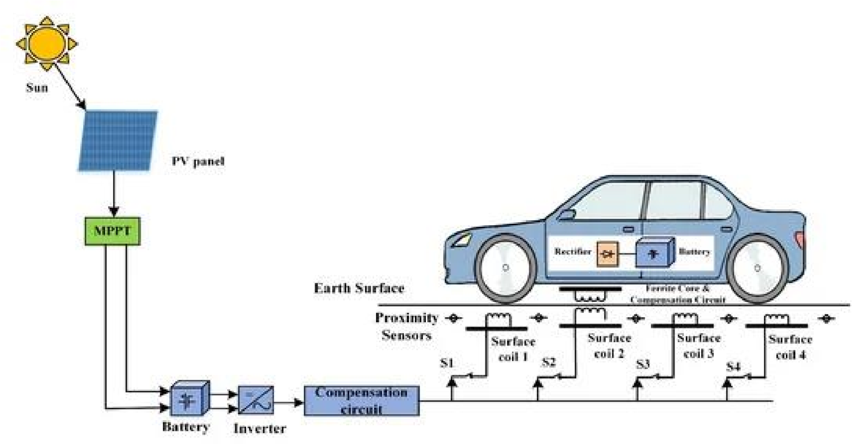

F**igure 5.** Schematic diagram of DWC.

**3. CONCLUSION**

The main principle of this WPT EV is induction principle (Electromagnetic induction). The road consists of the power which is delivered to the EV during the running condition as well as at the rest condition. The energy is transferred to the vehicle wirelessly. The main problem with the electric vehicle was the charging system because it is not possible to put the charging station in different places due to more cost and geographical difficulties. Therefore, to remove the charging problem the concept of wireless charging is used.

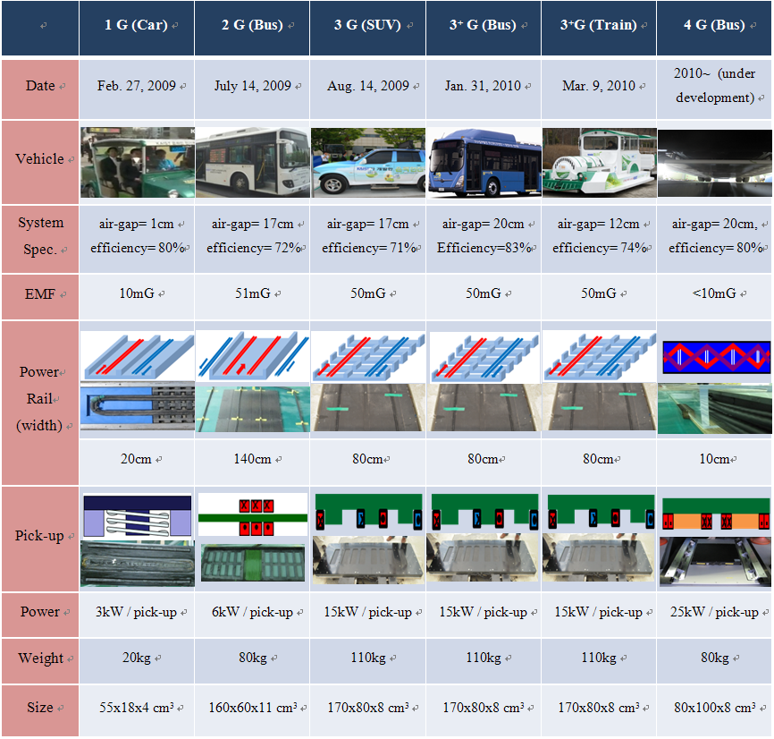

Figure 6:

This EV has made transportation more advanced and easier for us which has helped in utilization of the renewable source of the energy instead of the conventional source of the energy like petrol, diesel, coil etc.

**RECOMMENDATION**

The following measures should be taken to make effective implementation of Roadway powered electric vehicle with a view of providing uninterrupted and convenient charging, eliminating the need for frequent stops at conventional charging stations.

* Resources for ongoing research and development to advance roadway powered electric vehicle technology should be allocated.
* These factors such as power transfer efficiency, installation costs, and compatibility with different electric vehicle models should be considered.
* Various advantages such as environmental advantages, reduced dependency on traditional charging infrastructure should be highlighted.
* The staff of various companies should participate in conferences, workshops, and working groups to share experiences, best practices, and technological advancements.
* Public-private partnerships should be opened for financial support.
* Government should provide a facility and area for private companies to implement this project.
* The Ministry of Energy, Water Resources and Irrigation should provide additional training to the engineers to become clear and wide understanding of this project.

**GLOSSARY**

* **Wireless Charging:** A technology that enables electric vehicles to charge their batteries while driving through embedded or overhead charging infrastructure, utilizing electromagnetic fields to transfer power wirelessly.
* **Electric Vehicle (EV)**: A vehicle that uses electric motors or traction motors for propulsion, relying on electricity stored in batteries or obtained from an external power source, such as charging stations.
* **Inductive Charging:** A method of wireless charging that uses electromagnetic fields to transfer energy between a charging pad on the road surface and a receiving pad on the underside of an electric vehicle, without the need for physical connections.
* **Conductive Charging:** A charging method that involves physical connections between the charging infrastructure and the electric vehicle, typically using charging cables or plugs.
* **Power Transfer Efficiency:** The ratio of power transferred to an electric vehicle's battery during charging, compared to the power supplied by the charging infrastructure. Higher power transfer efficiency indicates more effective and efficient charging.
* **Charging Station:** A physical location where electric vehicles can connect to a power source to charge their batteries. It can be located on the roadside, in parking lots, or at designated charging stations.
* **Charging Connector:** The physical interface on an electric vehicle that connects to the charging infrastructure to facilitate the transfer of electrical power.
* **Public Charging Infrastructure:** Charging stations or points available for public use, typically located in public areas, such as shopping centers, parking lots, or along roadways.
* **Charging Network:** Companies or organizations that operate and manage a network of charging stations, offering services such as access cards, payment systems, and maintenance.
* **Dynamic Charging:** Electric vehicles charge their batteries while driving through overhead charging infrastructure, utilizing electromagnetic fields to transfer power wirelessly.

**INDEX**

Conclusion-9

Discussion-2

Dynamic Charging-7

Inductive Power Transfer-5

Introduction-1

Static Charging-6

Recommendation-10

Traction Battery-3

Working Principle of the WPT EV-3

**REFERENCE**

1. J. G. Bolger and F. A. Kirsten, Investigation of the feasibility of a dual mode electric transportation system, Lawrence Berkeley Laboratory Report, LBL6301, May 1977.
2. Santa Barbara Electric Bus Project, Phase 3A-final report, Santa Barbara Research Paper, Sept. 1983.
3. [Benitto Albert Rayan](https://sciprofiles.com/profile/author/R0ozTWhoL2Y5REVQbllHR1VTNVpWY2w1ODBWN0YxOGhtNlk4Y2V3VnZkaz0=) ,[Umashankar Subramaniam](https://sciprofiles.com/profile/608096), Wireless Power Transfer in Electric Vehicles: A Review on Compensation Topologies, Coil Structures, and Safety Aspects
4. Sasaki, S.; Tanaka, K.; Maki, K.I. Microwave power transmission technologies for solar power satellites. *Proc. IEEE* 2013, *101*, 1438–1447.
5. Choi, S.Y.; Gu, B.W.; Jeong, S.Y.; Rim, C.T. Advances in wireless power transfer systems for roadway-powered electric vehicles. *IEEE J. Emerg. Sel. Top. Power Electron.* 2015, *3*, 18–36.
6. Mi, C.C.; Buja, G.; Choi, S.Y.; Rim, C.T. Modern Advances in Wireless Power Transfer Systems for Roadway Powered Electric Vehicles. *IEEE Trans. Ind. Electron.* **2016**, *63*, 6533–6545.